SOC ANALYST INVESTIGATION REPORT
Network Traffic Analysis | SOC4.pcapng

Analyst | Manmeet Kaur
Date | April 2026
Classification | CONFIDENTIAL — Lab Exercise
Status | COMPLETED — TRUE POSITIVE CONFIRMED
Tool Used | Wireshark, VirusTotal, CyberChef
PCAP File | SOC4.pcapng
Total Packets | 62,965

1. Executive Summary
This report documents a complete network traffic analysis of the PCAP file SOC4.pcapng, conducted as a hands-on SOC Tier 1 analyst exercise. The analysis involved 62,965 packets captured over a period of approximately 4 minutes from two internal hosts (10.0.2.15 and 10.0.2.16).

The investigation identified one confirmed True Positive: the victim host 10.0.2.16 exhibited classic DNS beaconing behavior by repeatedly querying the domain audienceexposure.com at intervals of approximately 5 seconds. This pattern is consistent with malware attempting to establish Command and Control (C2) communication. The C2 server was unreachable during the capture period, resulting in repeated DNS Server Failure responses.

A secondary finding regarding IP 146.190.62.39 (httpforever.com) was investigated thoroughly and determined to be a False Positive — normal browser traffic initiated by the user via a Google search.

INCIDENT VERDICT: TRUE POSITIVE
Host 10.0.2.16 is infected with malware actively beaconing to C2 domain audienceexposure.com every ~5 seconds. Immediate isolation and forensic imaging of the host is recommended.

2. Environment & Tools
Component | Details
Analysis Platform | Kali Linux VM (VirtualBox)
Primary Tool | Wireshark 4.x
Threat Intel | VirusTotal.com, Criminal IP
PCAP File | SOC4.pcapng
Victim Host | 10.0.2.16 (Internal — Ubuntu Linux, Firefox browser)
Secondary Host | 10.0.2.15 (Internal)
DNS Server | 192.168.10.1 (Internal resolver)
Total Packets | 62,965

3. Investigation Methodology
The following structured SOC analyst workflow was applied to this investigation:

- Step 1: Capture File Properties — Determined total packet count, duration and interfaces
- Step 2: Protocol Hierarchy — Identified all protocols present in the traffic
- Step 3: Conversations (IPv4) — Identified top-talking IP pairs sorted by data volume
- Step 4: HTTP Filter — Examined all unencrypted HTTP requests and responses
- Step 5: Data-Text-Lines Filter — Identified plain text HTTP responses
- Step 6: VirusTotal IP Lookup — Verified external IPs against threat intelligence
- Step 7: TCP Stream Analysis — Read full HTTP conversations for suspicious content
- Step 8: JavaScript File Extraction — Analyzed downloaded JS files for malicious code
- Step 9: POST Request Check — Verified absence of outbound data exfiltration
- Step 10: DNS Analysis — Identified domain beaconing patterns
- Step 11: VirusTotal Domain Lookup — Verified suspicious domains against threat intel

4. Findings

4.1 Protocol Hierarchy Analysis
The Protocol Hierarchy (Statistics > Protocol Hierarchy) revealed the following traffic composition across 62,965 packets:

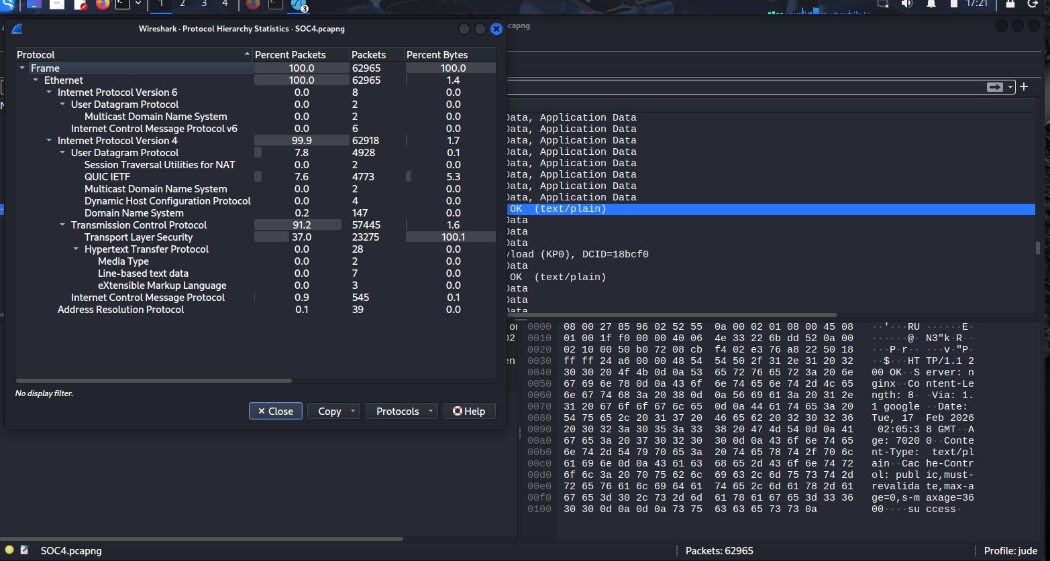
Figure 1 — Wireshark Protocol Hierarchy Statistics showing traffic breakdown

Protocol | Packets | % of Traffic | Significance
IPv4 | 62,918 | 99.9% | All traffic is IPv4 — no anomalies
TCP | 57,445 | 91.2% | Normal connection-oriented traffic
TLS (Transport Layer Security) | 23,275 | 37% | Encrypted HTTPS — expected
QUIC | 4,773 | 7.6% | Google services (YouTube, Chrome)
HTTP (Unencrypted) | 28 packets | 0.04% | Readable — primary investigation target
DNS | 147 packets | 0.2% | Domain lookups — investigated
Line-based Text Data | 7 packets | 0.01% | Plain text responses — flagged

Key observation: While most traffic was encrypted (TLS/QUIC), the 28 HTTP packets were unencrypted and readable, making them the primary investigation focus.

4.2 Conversations Analysis — Top Talkers
The Conversations view (Statistics > Conversations > IPv4) was sorted by Bytes to identify the most active communication pairs:

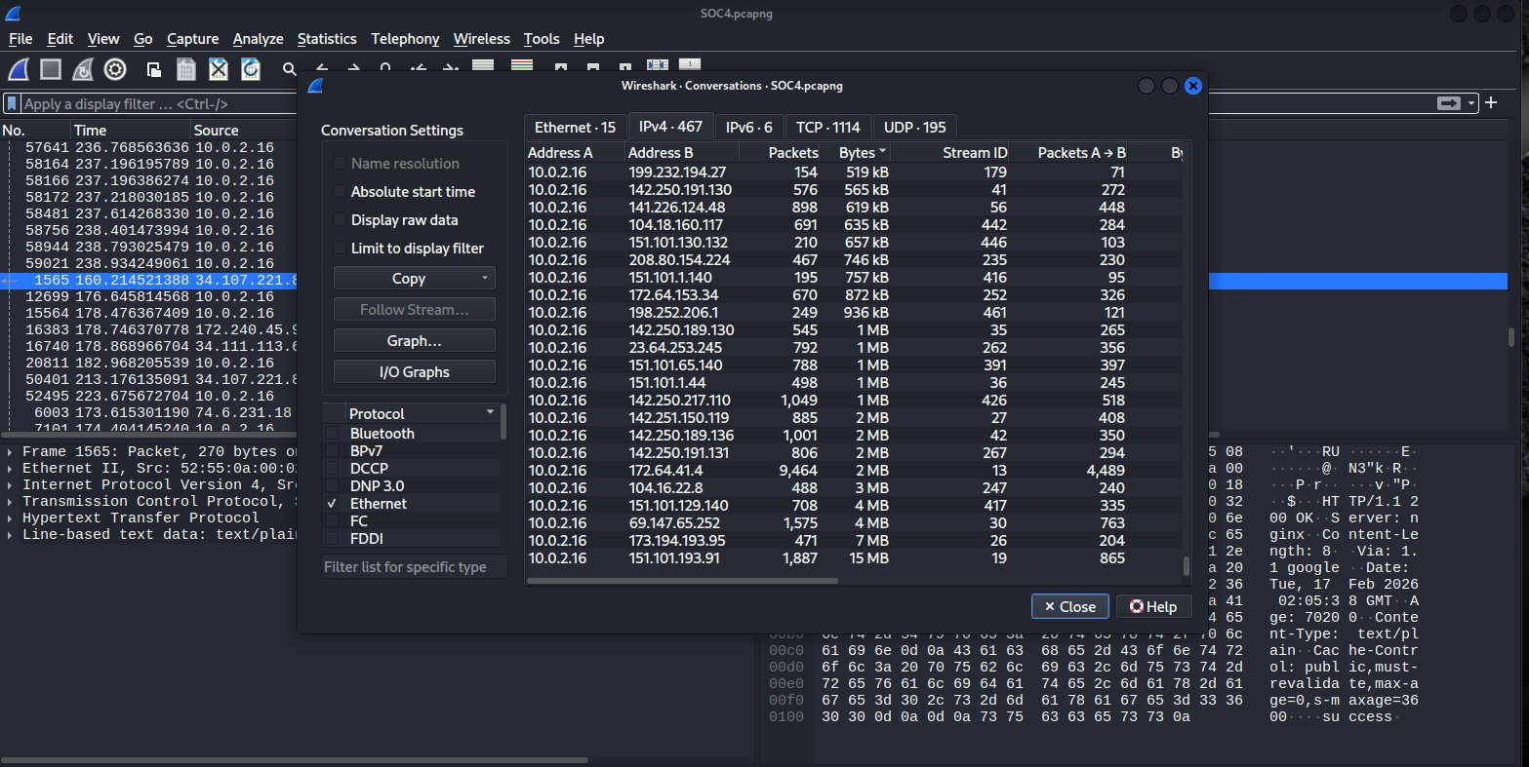
Figure 2 — IPv4 Conversations sorted by Bytes, victim host 10.0.2.16 highlighted

External IP | Data Volume | Priority | Outcome
151.101.193.91 | 15 MB | HIGH — investigated first | VirusTotal: CLEAN (Fastly CDN)
173.194.193.95 | 7 MB | Medium | Google infrastructure — clean
69.147.65.252 | 4 MB | Medium | Yahoo CDN — clean
146.190.62.39 | 3 MB | HIGH — flagged | VirusTotal: 1/94 MALICIOUS
104.16.22.8 | 3 MB | Low | Cloudflare — clean

4.3 HTTP Traffic Analysis
Applying the filter http revealed all unencrypted web requests. The victim host 10.0.2.16 made GET requests to two external servers:

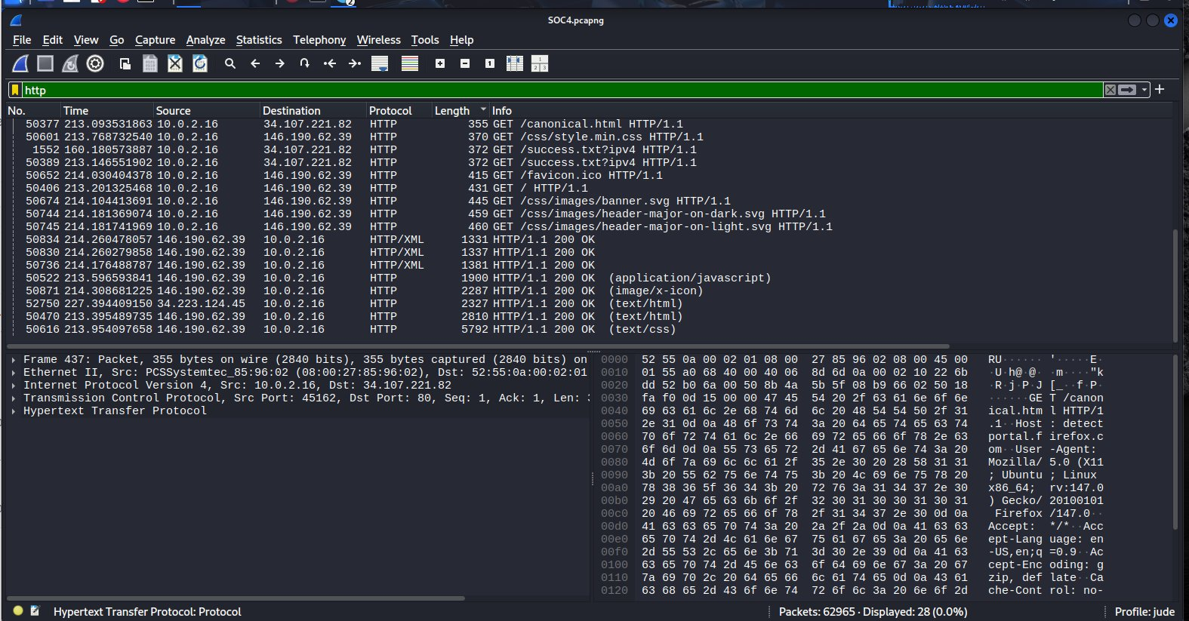
Figure 3 — HTTP filter showing GET requests from victim host 10.0.2.16

Destination IP | Request | Content-Type | Assessment
34.107.221.82 | GET /canonical.html, /success.txt | text/plain | Firefox captive portal check — CLEAN
146.190.62.39 | GET /, /js/init.min.js, /css/style.min.css | text/html, CSS, JS | httpforever.com — INVESTIGATED
34.223.124.45 | GET / | text/html | Normal web response — CLEAN

4.4 Investigation of IP 146.190.62.39 (httpforever.com) — False Positive
IP 146.190.62.39 was flagged by one VirusTotal vendor (Criminal IP) as malicious. A thorough investigation was conducted.

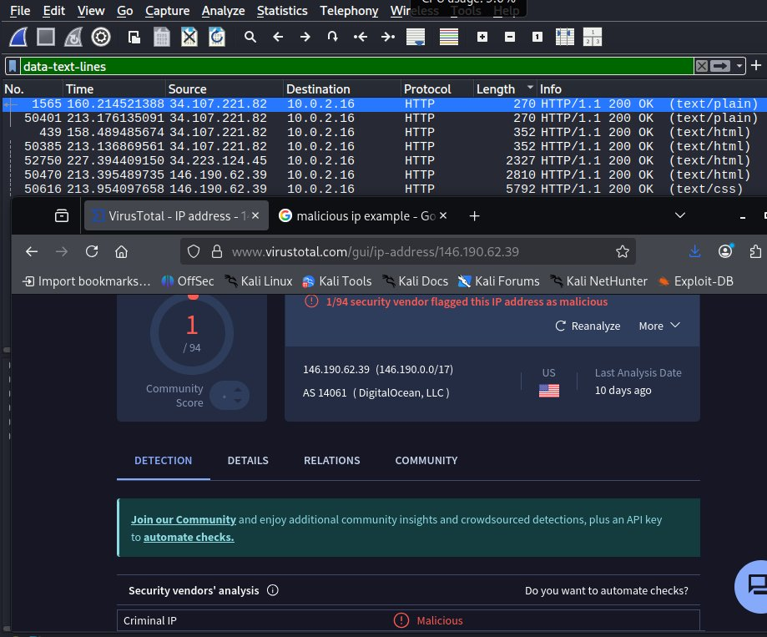
Figure 4 — VirusTotal result for 146.190.62.39 showing 1/94 detection by Criminal IP

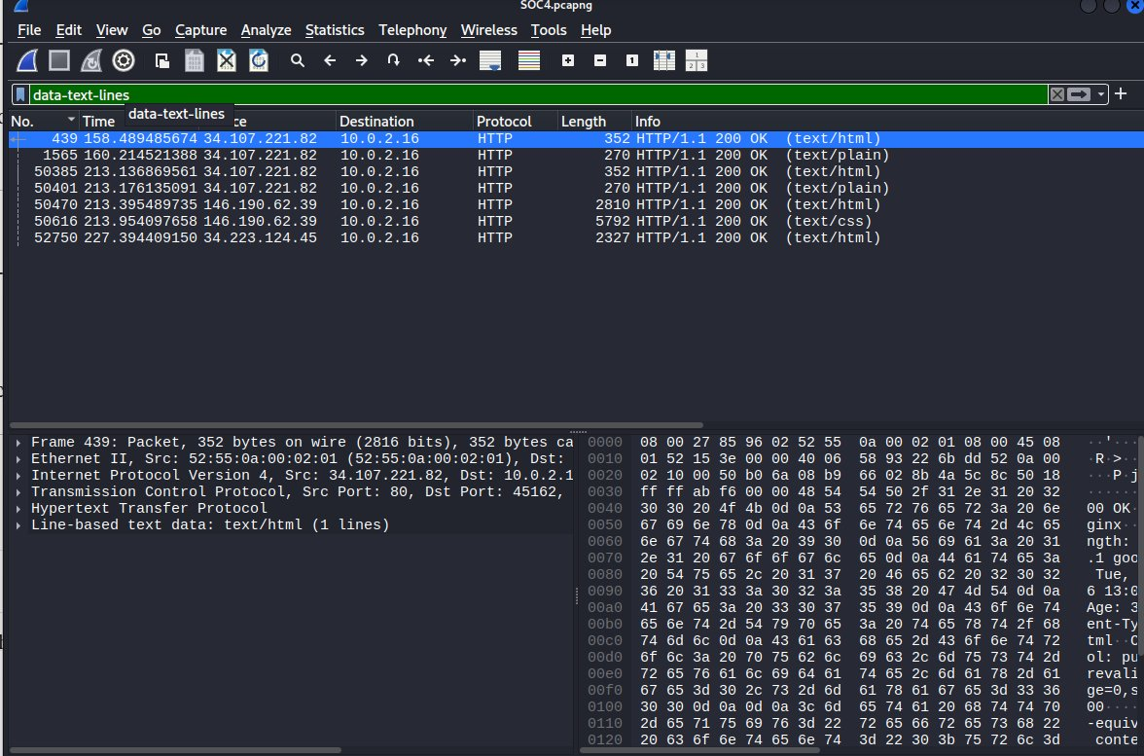
Figure 5 — data-text-lines filter showing HTTP responses including 146.190.62.39 traffic

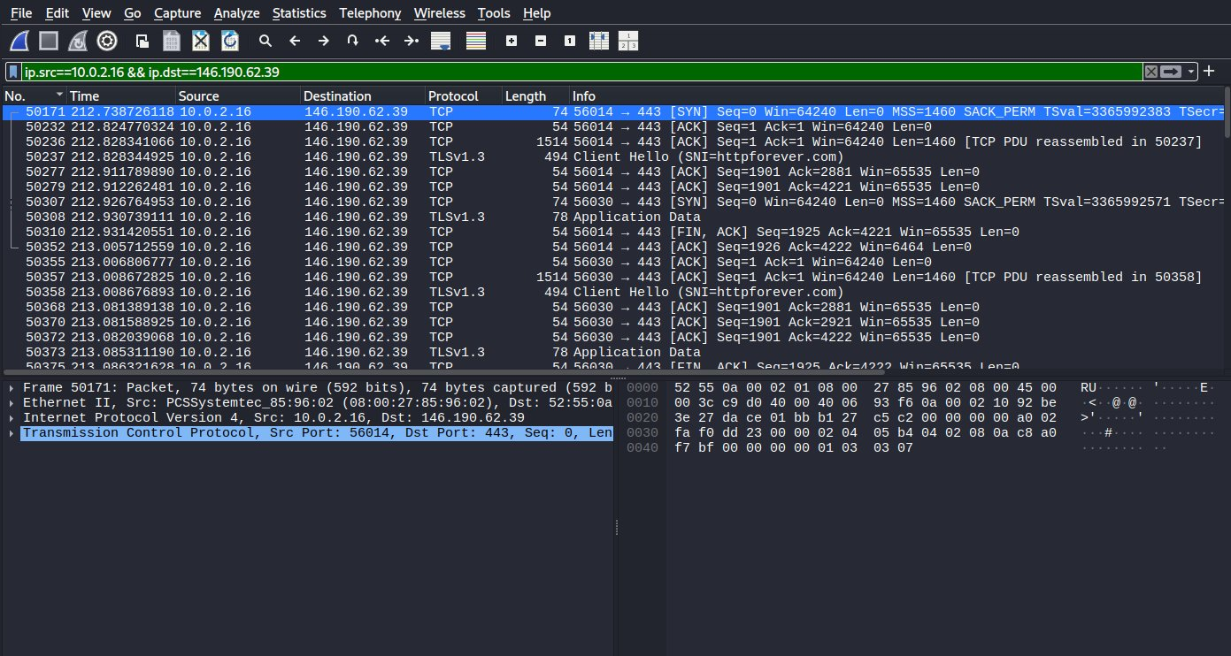
Figure 6 — Outbound traffic filter (ip.src==10.0.2.16 && ip.dst==146.190.62.39) showing TLS connection to httpforever.com

The TCP stream analysis revealed the following evidence:

- User-Agent: Mozilla/5.0 Firefox/147.0 on Ubuntu Linux — confirms real browser, not automated script
- Referer: https://www.google.com/ — user arrived from a Google search, not malware-triggered
- Downloaded files: HTML, CSS (style.min.css), JavaScript (init.min.js), SVG images — all clean
- JavaScript analysis: init.min.js is the Skel.js CSS responsive framework (2015-era) — no obfuscation, eval(), or Base64 encoding
- XML content (HTTP/XML packets): The XML was an SVG decorative banner image — not C2 configuration data

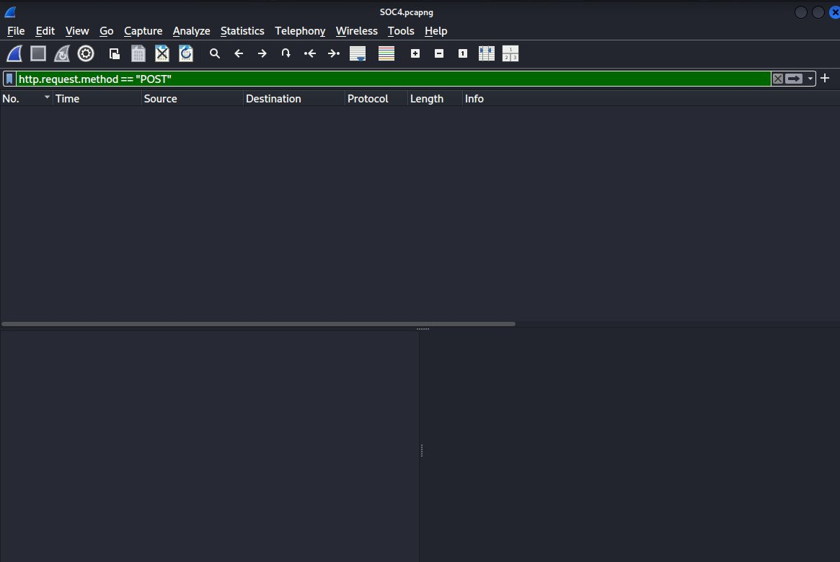
Figure 7 — Zero POST requests confirmed — no data exfiltration to 146.190.62.39

VERDICT: FALSE POSITIVE
146.190.62.39 (httpforever.com) — Normal user browsing via Google search. Zero POST requests. No malicious files downloaded. No data exfiltration. The 1/94 VirusTotal detection is a low-confidence false positive.

4.5 DNS Analysis — C2 Beaconing Discovered
DNS traffic was filtered and analyzed for suspicious domain query patterns. The filter dns revealed 147 DNS queries. The majority were normal browser and OS activity (google.com, youtube.com, mozilla.org, connectivity-check.ubuntu.com).

One domain stood out immediately due to a highly anomalous query pattern:

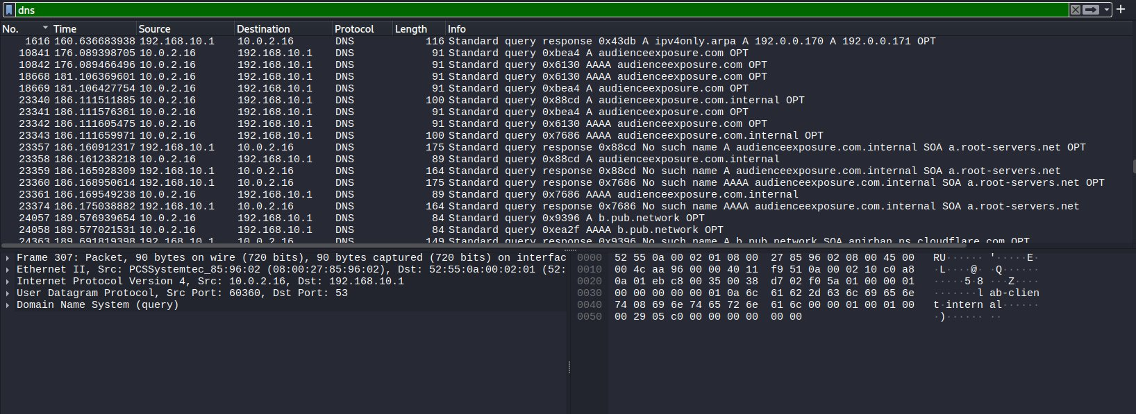
Figure 8 — DNS filter showing audienceexposure.com beaconing every ~5 seconds from 10.0.2.16

The domain audienceexposure.com was queried repeatedly by host 10.0.2.16 at precise 5-second intervals across the entire capture duration:

Frame | Timestamp | Query | Response | Interval
10841 | 176.089s | A audienceexposure.com | No response (timeout) | —
18668 | 181.106s | AAAA audienceexposure.com | No response | ~5 seconds
23341 | 186.111s | A audienceexposure.com | No such name | ~5 seconds
27079 | 191.225s | A audienceexposure.com | No such name | ~5 seconds
35210 | 196.477s | A audienceexposure.com | No such name | ~5 seconds
43062 | 201.725s | A audienceexposure.com | No such name | ~5 seconds
47908 | 206.976s | A audienceexposure.com | Server failure | ~5 seconds
49820 | 212.225s | AAAA audienceexposure.com | Server failure | ~5 seconds

This behavior is textbook DNS beaconing — a hallmark of malware maintaining persistent contact attempts with a Command and Control (C2) server. Unlike human browsing behavior, the queries are automated, precisely timed, and continue regardless of DNS failure responses.

4.6 Threat Intelligence — audienceexposure.com
The domain audienceexposure.com was submitted to VirusTotal for threat intelligence analysis:

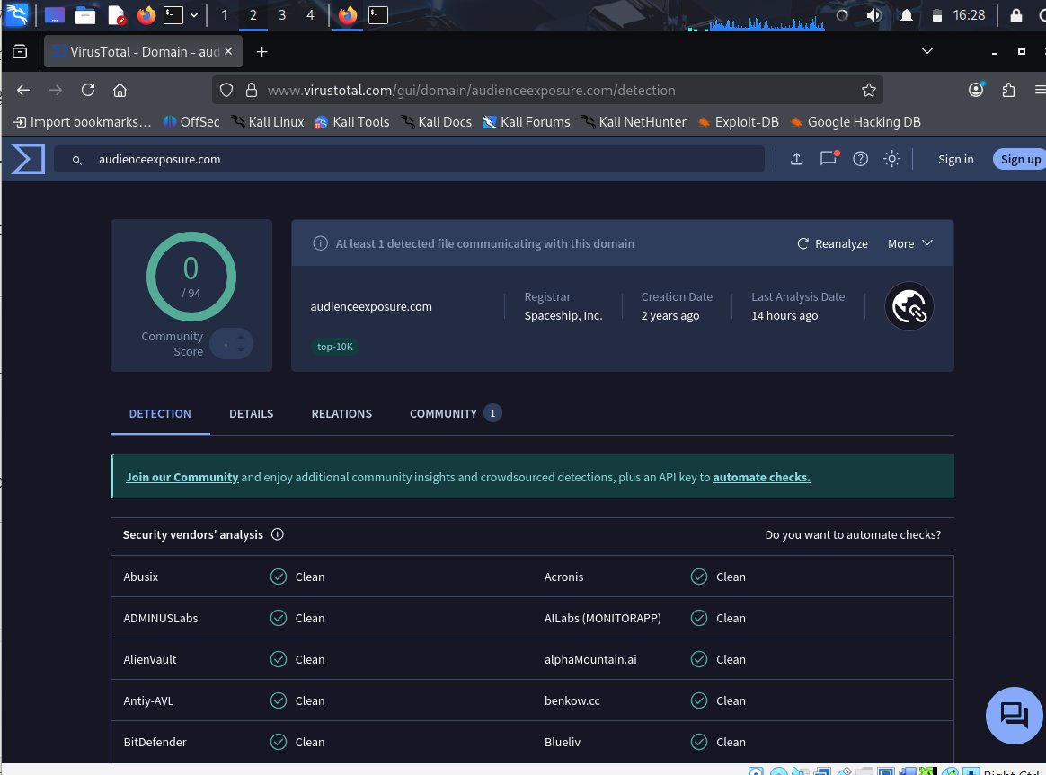
Figure 9 — VirusTotal Detection tab for audienceexposure.com

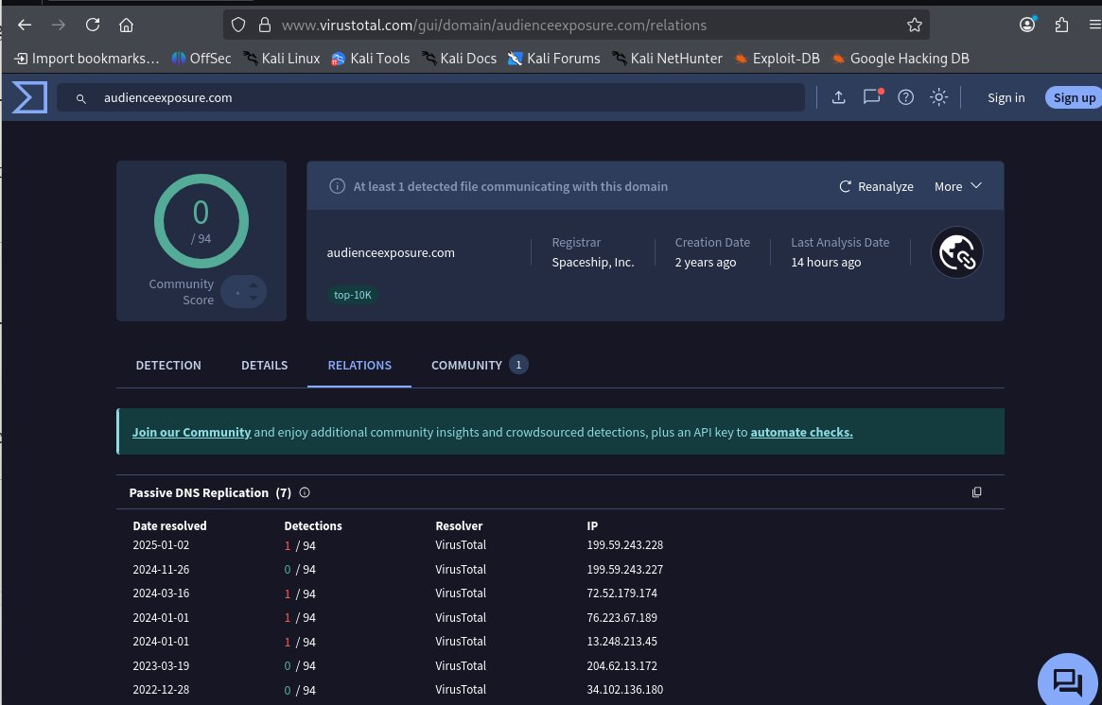
Figure 10 — VirusTotal Relations tab showing at least 1 detected file communicating with this domain and Passive DNS history with multiple 1/94 detections

Indicator | Finding
VirusTotal notice | At least 1 detected file communicating with this domain
Passive DNS detections | Multiple historical 1/94 malicious detections (2022-2025)
Registrar | Spaceship, Inc.
Domain age | 2 years
Last analysis | 14 hours ago
Associated IPs | 199.59.243.228, 72.52.179.174, 76.223.67.189 (all flagged 1/94)

The presence of a known malicious file communicating with this domain confirms that audienceexposure.com is associated with malware C2 infrastructure. The Passive DNS records show this domain has been consistently flagged across multiple analysis dates from 2022 to 2025.

5. Complete Findings Summary
Domain / IP | Type | Verdict | Evidence
151.101.193.91 | External IP | CLEAN | 15MB — Fastly CDN, 0/94 on VirusTotal
146.190.62.39 | External IP | FALSE POSITIVE | httpforever.com, browser-initiated, no POST, JS clean
google.com, youtube.com | DNS Domains | CLEAN | Normal user browsing activity
connectivity-check.ubuntu.com | DNS Domain | CLEAN | Standard Ubuntu OS behavior
detectportal.firefox.com | DNS Domain | CLEAN | Firefox captive portal detection (led to httpforever.com)
b.pub.network | DNS Domain | SUSPICIOUS | Unresolvable, unusual naming — no connection established
audienceexposure.com | C2 Domain | TRUE POSITIVE | DNS beaconing every 5s, VirusTotal file association confirmed

6. Attack Timeline
Time (seconds) | Event | Significance
0–157s | Normal OS startup DNS queries (Ubuntu connectivity checks) | Baseline traffic
157–214s | User opens Firefox — browser initialization DNS queries | Normal behavior
158s | User visits httpforever.com (via Google search) | False Positive — clean browsing
160s | Firefox establishes DoH (DNS-over-HTTPS) with Cloudflare | Normal browser behavior
176s | FIRST DNS query for audienceexposure.com from 10.0.2.16 | Malware C2 beacon begins
176–212s | Repeated DNS queries every ~5 seconds — all failing | Persistent C2 beacon attempts
206s onwards | DNS server returns Server failure for audienceexposure.com | C2 server unreachable — malware still tries
240s | Firefox telemetry sent to incoming.telemetry.mozilla.org | Normal Firefox behavior

7. Final Verdict & Recommendations
CONFIRMED INCIDENT — TRUE POSITIVE
Host 10.0.2.16 is infected with malware. The malware is actively beaconing to the C2 domain audienceexposure.com every 5 seconds. The C2 server is currently unreachable, however the malware remains installed and will resume communication when the server becomes available. Immediate action is required.

Recommended Actions
- 1. ISOLATE the host 10.0.2.16 from the network immediately to prevent C2 communication when the server recovers
- 2. FORENSIC IMAGE the host disk before remediation to preserve evidence
- 3. BLOCK the domain audienceexposure.com and all associated IPs at the firewall and DNS level
- 4. HUNT for audienceexposure.com DNS queries across all other internal hosts to identify lateral spread
- 5. SUBMIT the PCAP to the threat intel team for malware family identification
- 6. DOCUMENT the incident in the ticketing system with all IOCs listed in Section 8

8. Indicators of Compromise (IOCs)
IOC Type | Value | Confidence
C2 Domain | audienceexposure.com | HIGH
C2 IP (historical) | 199.59.243.228 | MEDIUM
C2 IP (historical) | 72.52.179.174 | MEDIUM
C2 IP (historical) | 76.223.67.189 | MEDIUM
C2 IP (historical) | 13.248.213.45 | MEDIUM
Victim Host | 10.0.2.16 | HIGH — confirmed infected
Beacon Interval | ~5 seconds (DNS A + AAAA queries) | HIGH
DNS Pattern | Repeated SERVFAIL on audienceexposure.com | HIGH

9. SOC Skills Demonstrated
Skill | Applied In This Investigation
Wireshark PCAP Analysis | Full traffic triage using Protocol Hierarchy, Conversations, filters
HTTP Traffic Inspection | Followed TCP streams, read headers, identified User-Agent patterns
JavaScript Code Analysis | Extracted and audited init.min.js for malicious obfuscation
False Positive Identification | Distinguished legitimate browsing from threat indicators
DNS Beaconing Detection | Identified C2 communication pattern via timed DNS queries
Threat Intelligence | Used VirusTotal for IP and domain reputation checks
IOC Extraction | Documented all Indicators of Compromise for blocking
Incident Documentation | Produced formal analyst report with evidence

End of Report — Prepared by Manmeet Kaur SOC Analyst Candidate | April 2026

